***NAME :: IBRAR BABAR***

**Roll no :: 19P-0104**

**DLD LAB :: SECTION ( 2B2 )**

***SIR YOUSAF***

**1-BIT MAGNITUDE COMPARATOR**

**TRUTH TABLE :**

|  |  |  |  |  |
| --- | --- | --- | --- | --- |
| **A** | **B** | **A>B** | **A=B** | **A<B** |
| **0** | **0** | **0** | **1** | **0** |
| **0** | **1** | **0** | **0** | **1** |
| **1** | **0** | **1** | **0** | **0** |
| **1** | **1** | **0** | **1** | **0** |

**K-map :**

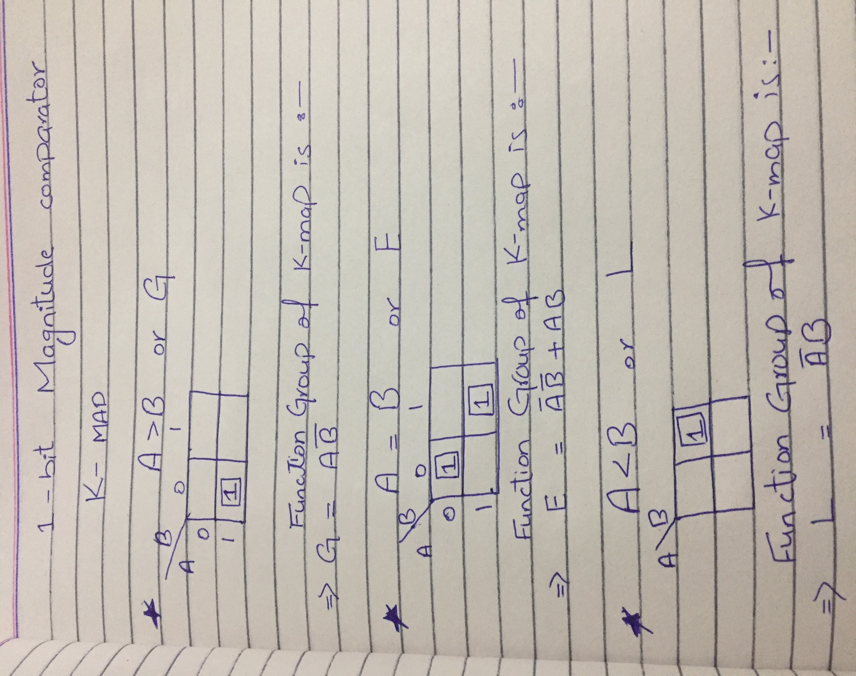

**Implementation:**

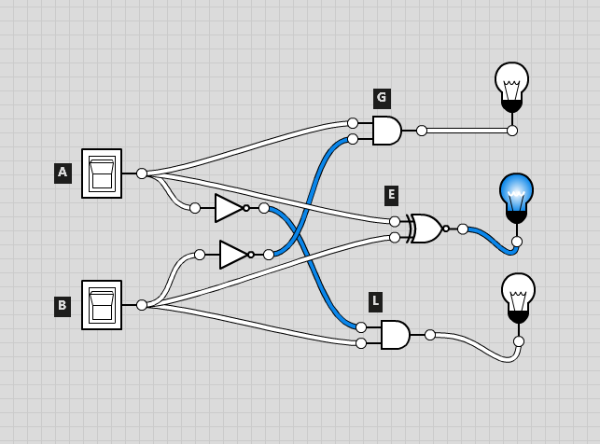

**===================================================================**

**2-BIT MAGNITUDE COMPARATOR**

|  |  |  |  |  |
| --- | --- | --- | --- | --- |
| **A1 A0** | **B1 B0** | **A>B** | **A=B** | **A<B** |
| **0 0** | **0 0** | **0** | **1** | **0** |
| **0 0** | **0 1** | **0** | **0** | **1** |
| **0 0** | **1 0** | **0** | **0** | **1** |
| **0 0** | **1 1** | **0** | **0** | **1** |
| **0 1** | **0 0** | **1** | **0** | **0** |
| **0 1** | **0 1** | **0** | **1** | **0** |
| **0 1** | **1 0** | **0** | **0** | **1** |
| **0 1** | **1 1** | **0** | **0** | **1** |
| **1 0** | **0 0** | **1** | **0** | **0** |
| **1 0** | **0 1** | **1** | **0** | **0** |
| **1 0** | **1 0** | **0** | **1** | **0** |
| **1 0** | **1 1** | **0** | **0** | **1** |
| **1 1** | **0 0** | **1** | **0** | **0** |
| **1 1** | **0 1** | **1** | **0** | **0** |
| **1 1** | **1 0** | **1** | **0** | **0** |
| **1 1** | **1 1** | **0** | **1** | **0** |

**K-map:**

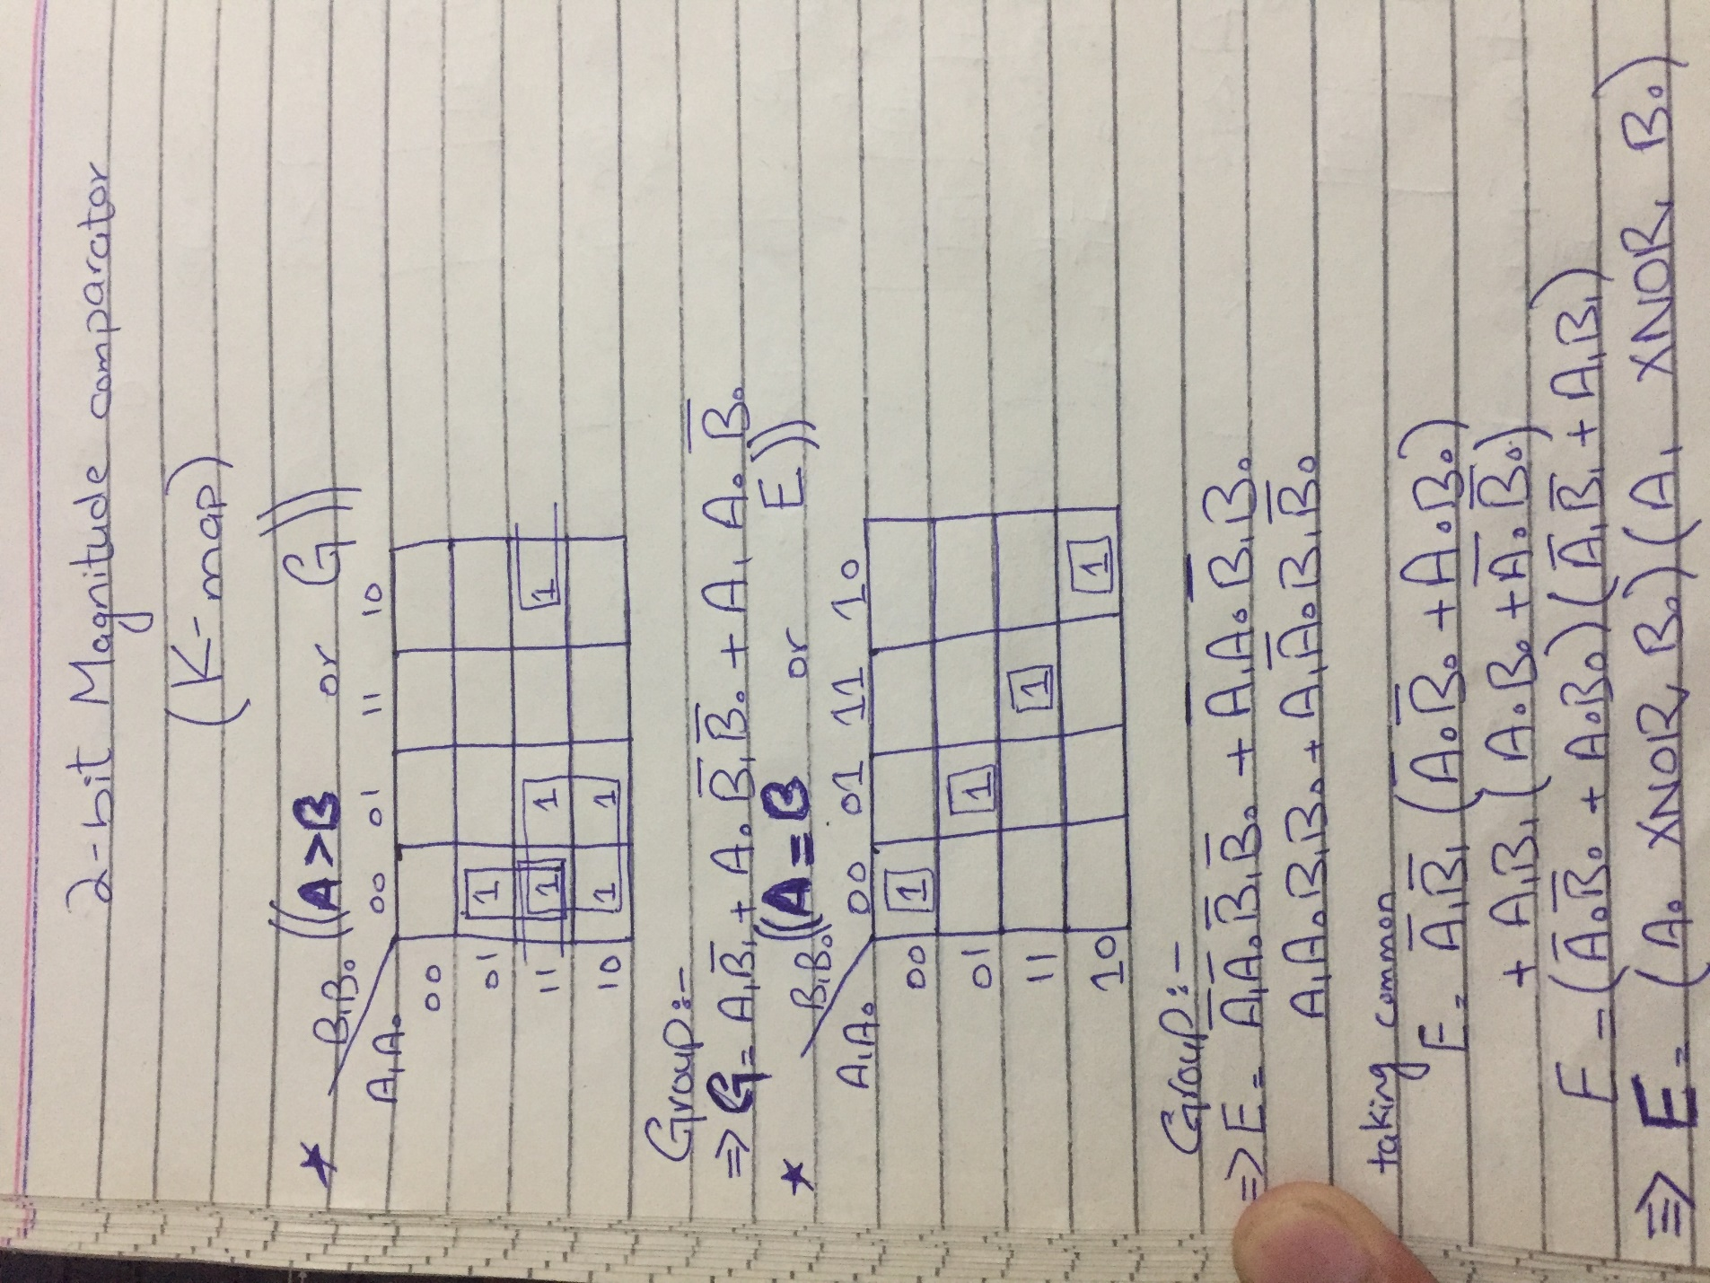

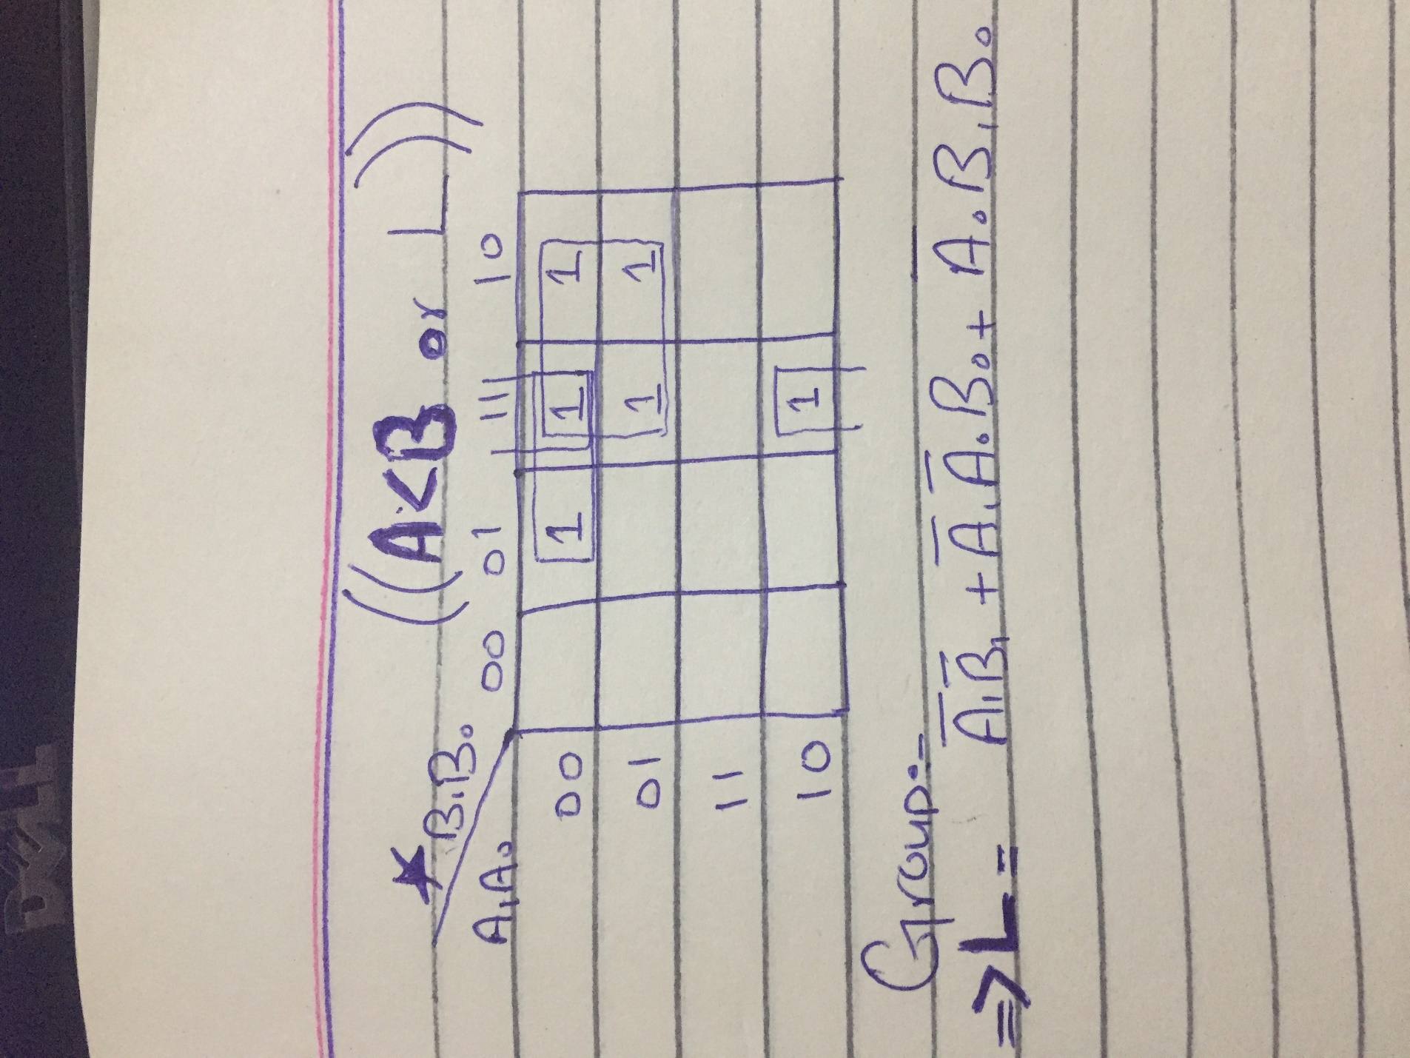

**IMPLEMENTATION:**

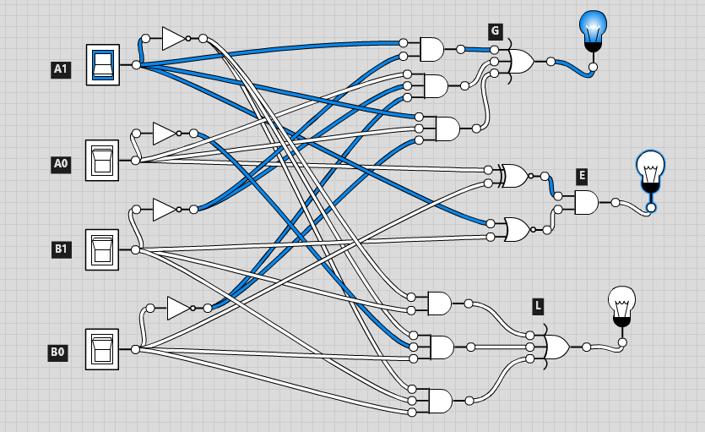

**4-BIT MAGNITUDE COMPARATOR**

**TRUTH TABLE:**

